**Advance Excel Assignment 1**

1. What do you mean by cells in an excel sheet?

* An excel worksheet is made of cells only which is nothing but intersection of a row and a column.
* Columns are represented by letters & rows by numbers in a cell.
* Example- If we are referring to cell B5 then B is the column & 5 is the row number.

1. How can you restrict someone from copying a cell from your worksheet?

* Give password to protect sheet in the review header of excel.

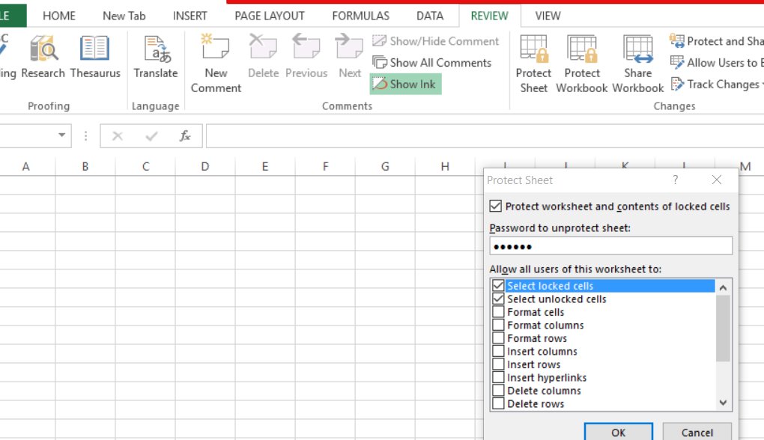

1. How to move or copy the worksheet into another workbook?

* In the below snippet Worksheet from Workbook2 has been copied to Worksbook1 using “Move or Copy” option of excel.
* If we don’t tick on “Create a copy” option then worksheet from Workbook2 will move to workbook1.

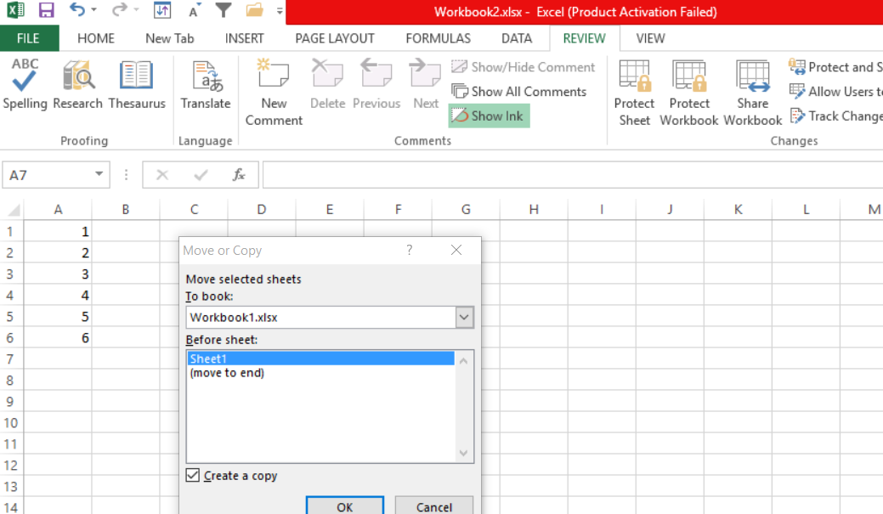

1. Which key is used as a shortcut for opening a new window document?

CTRL + N

1. What are the things that we can notice after opening the Excel interface?
2. Rectangular grid of cells.
3. Sheet name at the bottom of workbook.
4. Different headers- File, home, Insert, Page Layout, Data, Review, View
5. By default header will be home in excel wherein we get paste options in clipboard, Font & it’s size, Paint in font section, Alignment section, Number section like Currency, percentage, Styles- Conditional formatting, Editing section where we get Sort & filter options.
6. We can save this excel sheet by clicking on file header from menu bar.
7. When to use a relative cell reference in excel?

Relative cell reference is used when we want to use same formula across different rows/ columns for different values present there.

Example = In the below snippet formula used for A1* B1 can be dragged down to use it as a reference for the other rows. So, for C2 cell it will be A2* B2.

